Now search Replit in Google

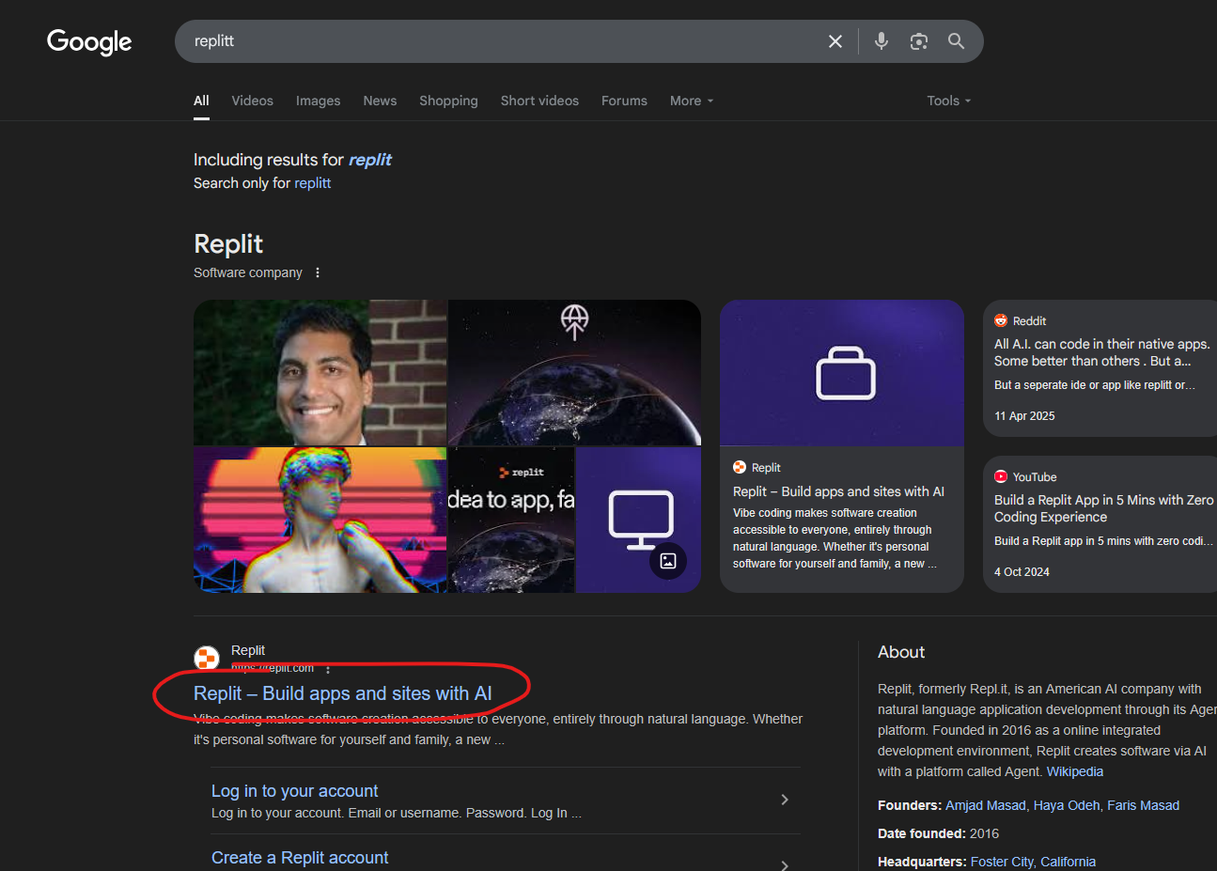

Now open the marked site

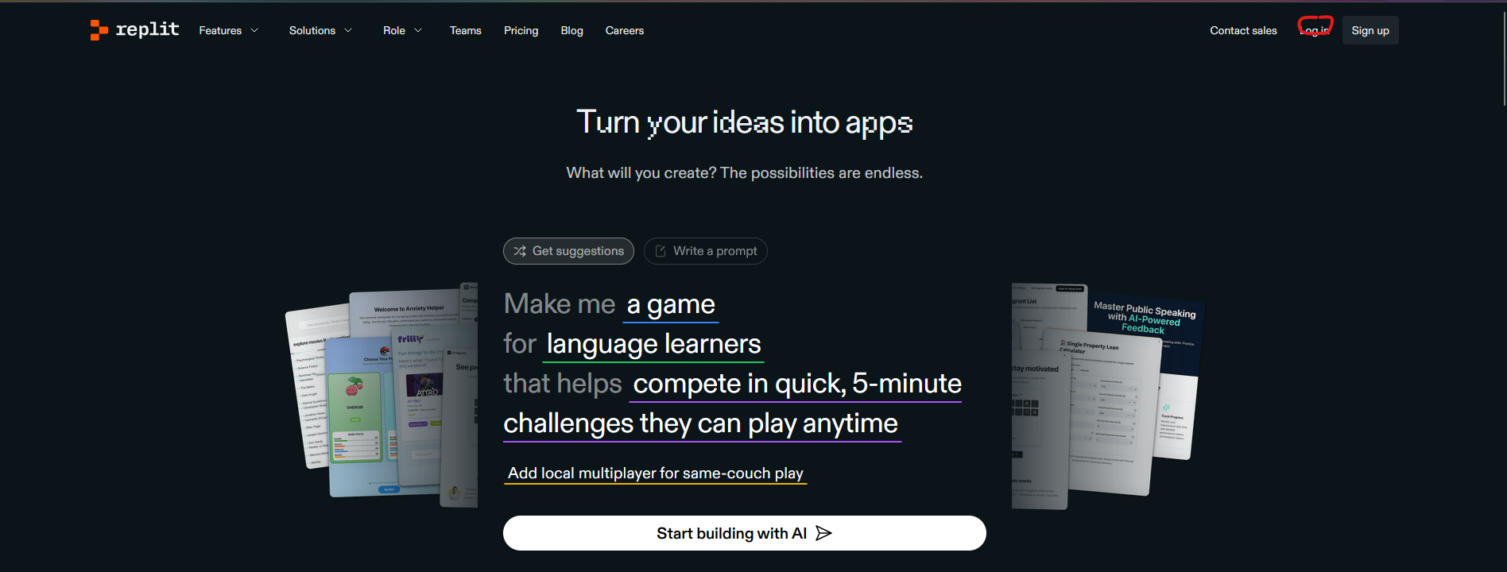

Now Replit home page opens as shown above

Now click on Login button as marked above

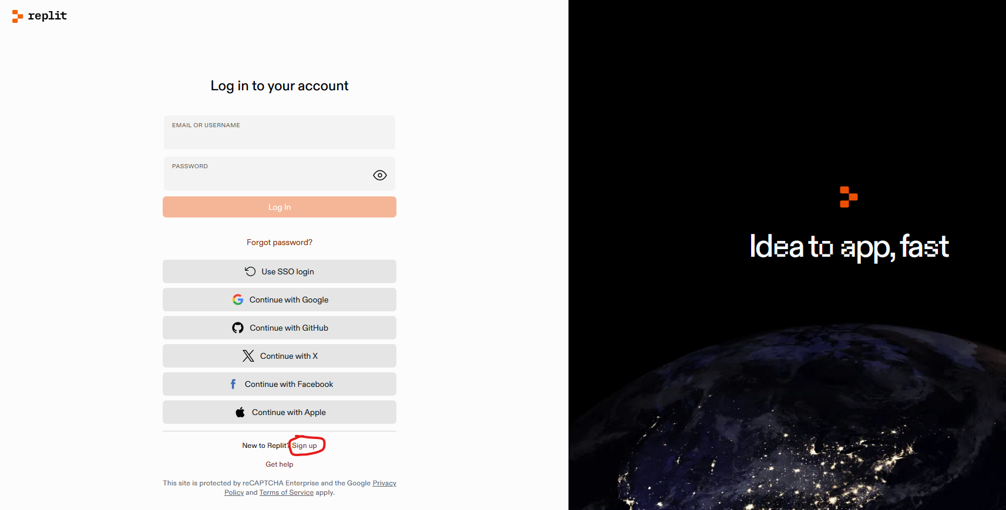

We don’t have account then go to Sign up

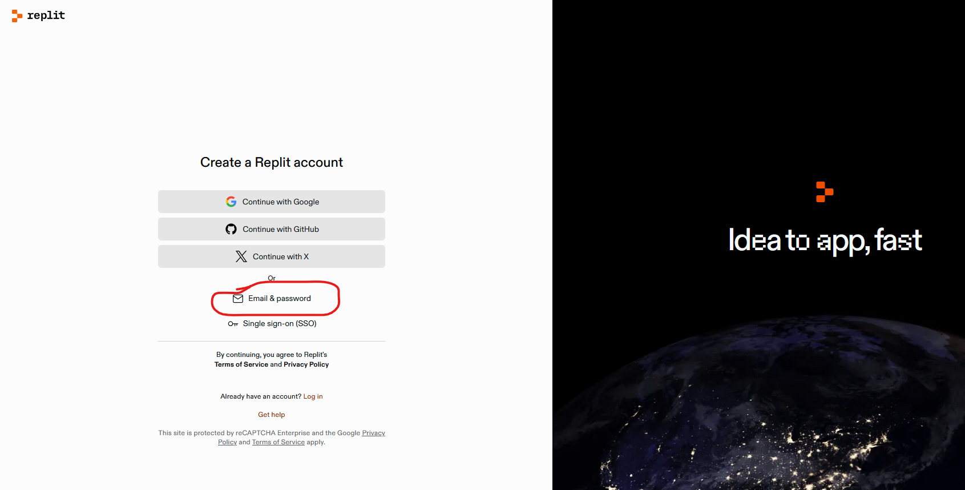

Now above page opens click on marked above to create account with email and password

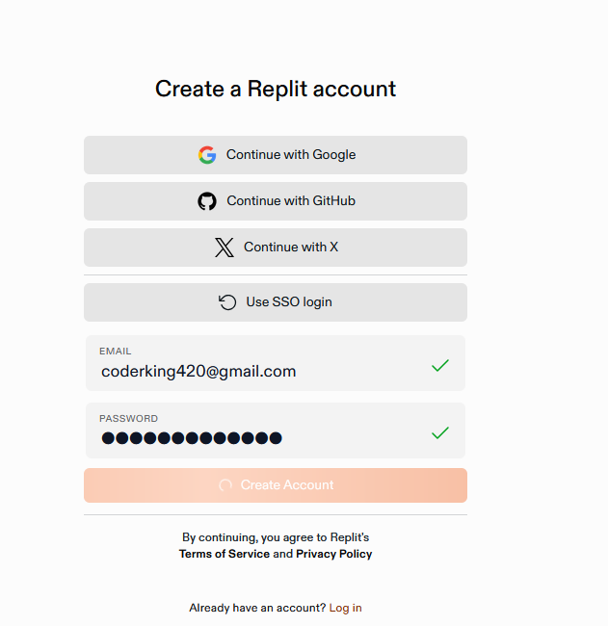

After entering the new email and password and then click on create account

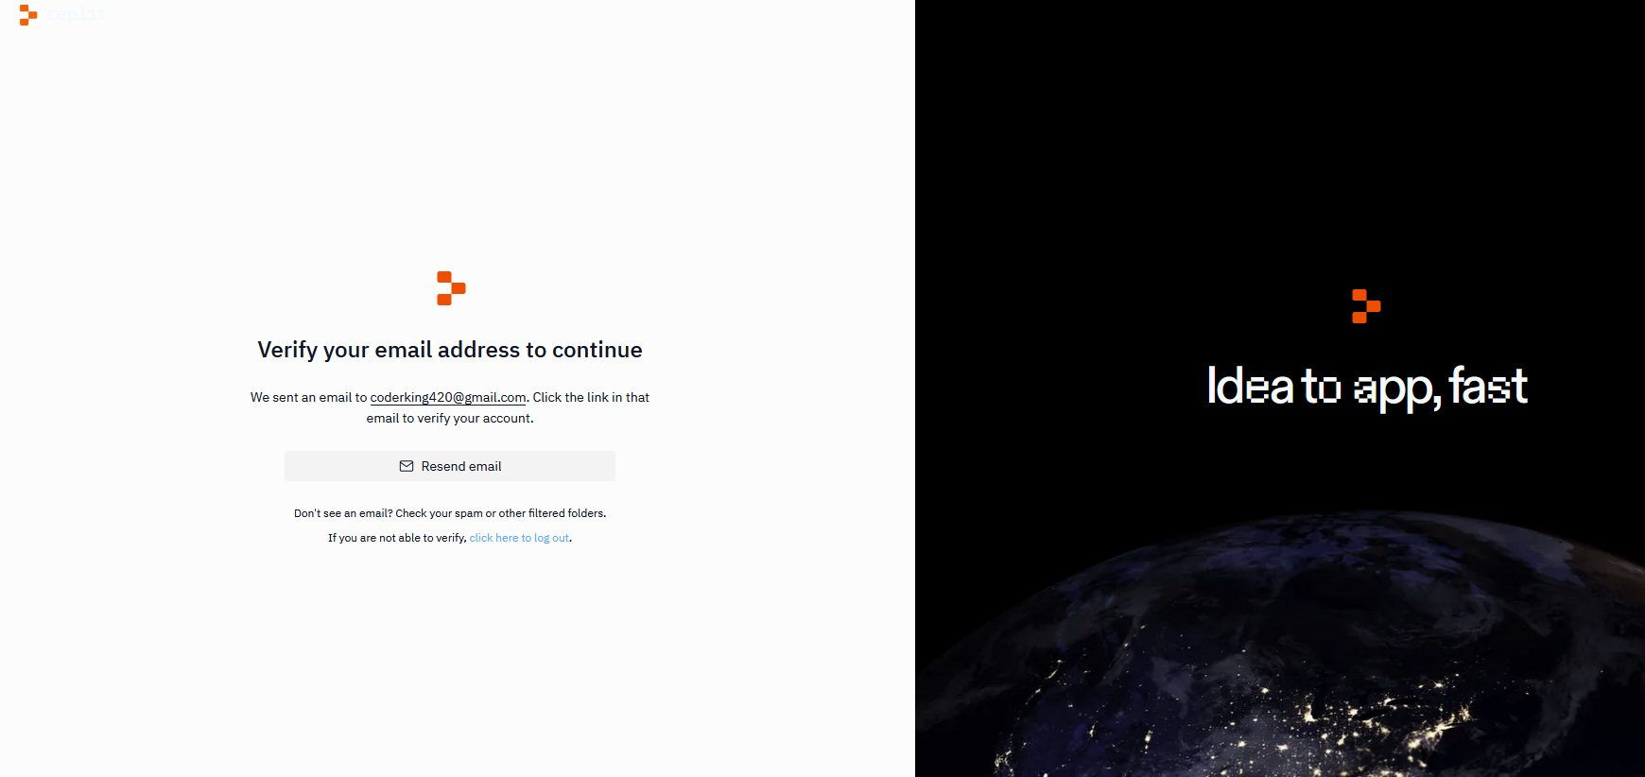

Now an email will be set to your email which you set for replit

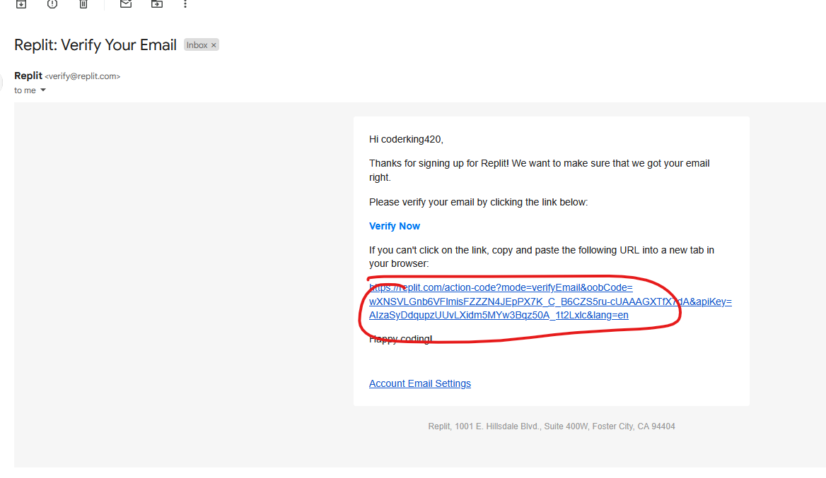

Click on the marked above link for email verification

When you click on this you will be directed to page below



Click on return to replit. It will direct to your account

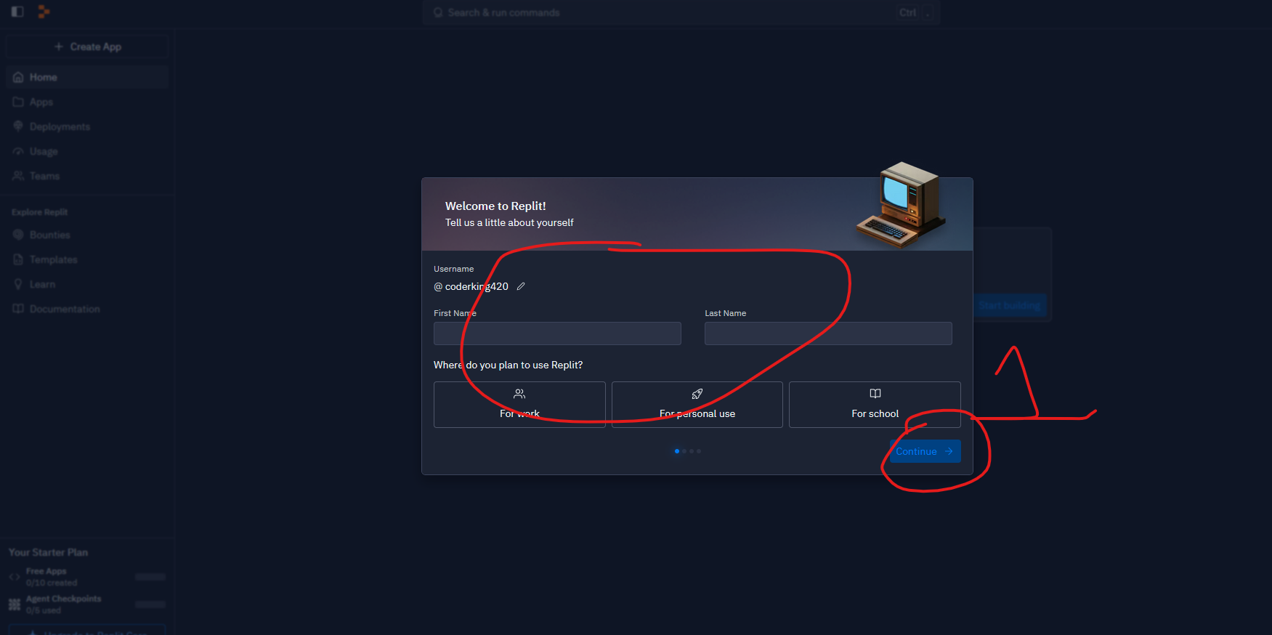

It will ask you some question as marked above

After filing click on continue button as marked 1

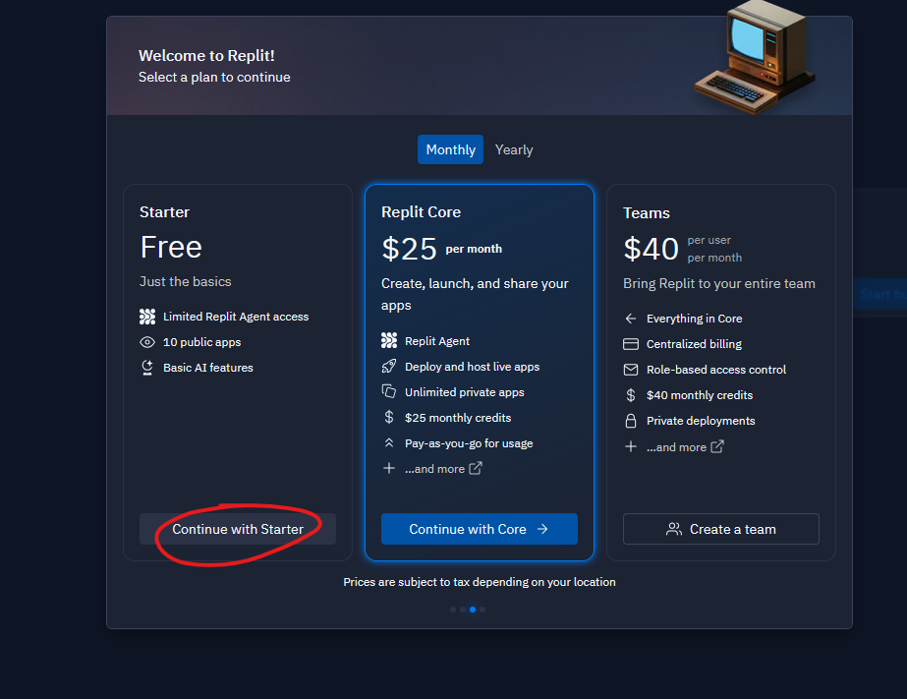

Click on continue with starter as marked above

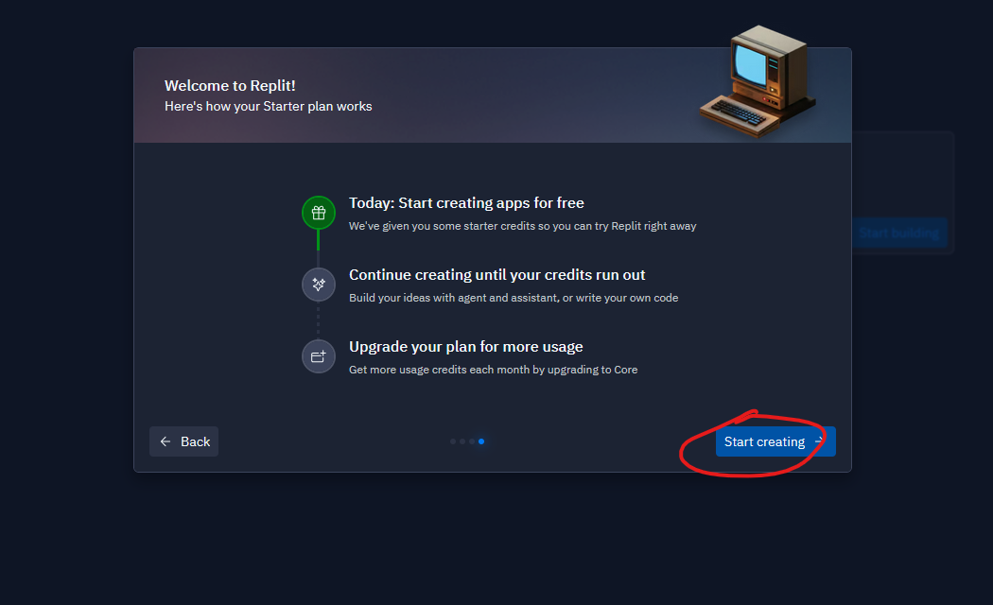

Click on Start creating

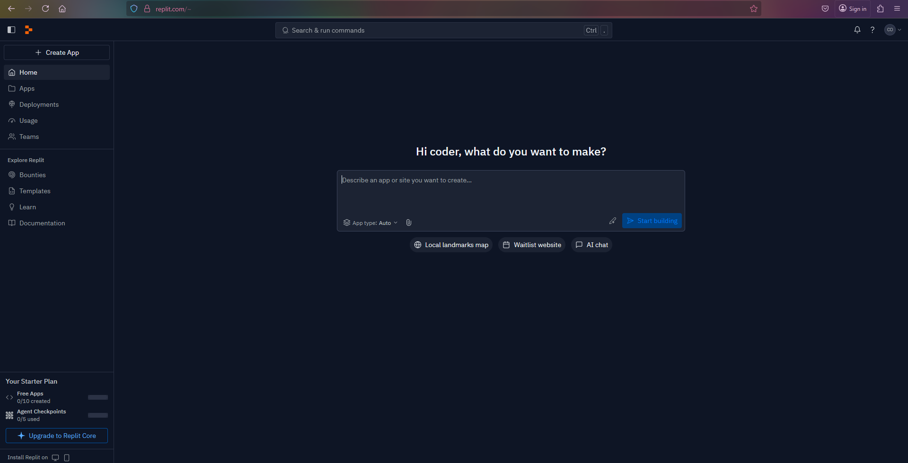

Now you can see the Home Interface of replit account.

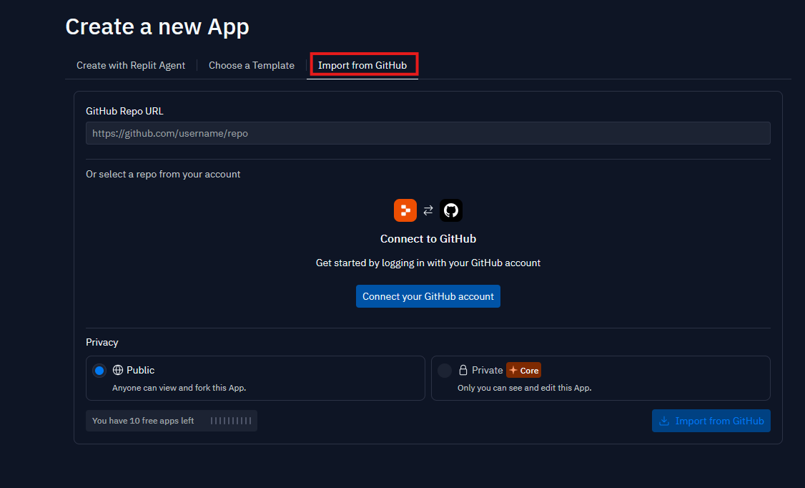

Now click on import from Github as marked above

And then click on Connect you Github account as marked 1 below

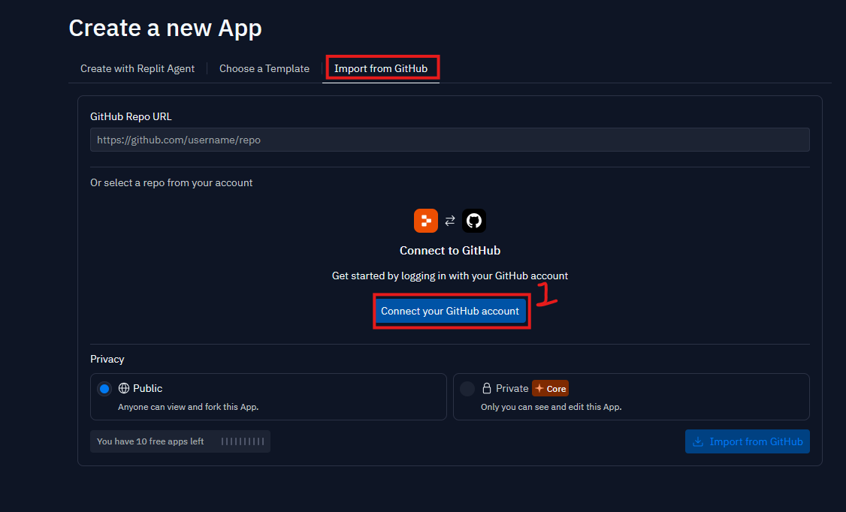

Now a new page opens

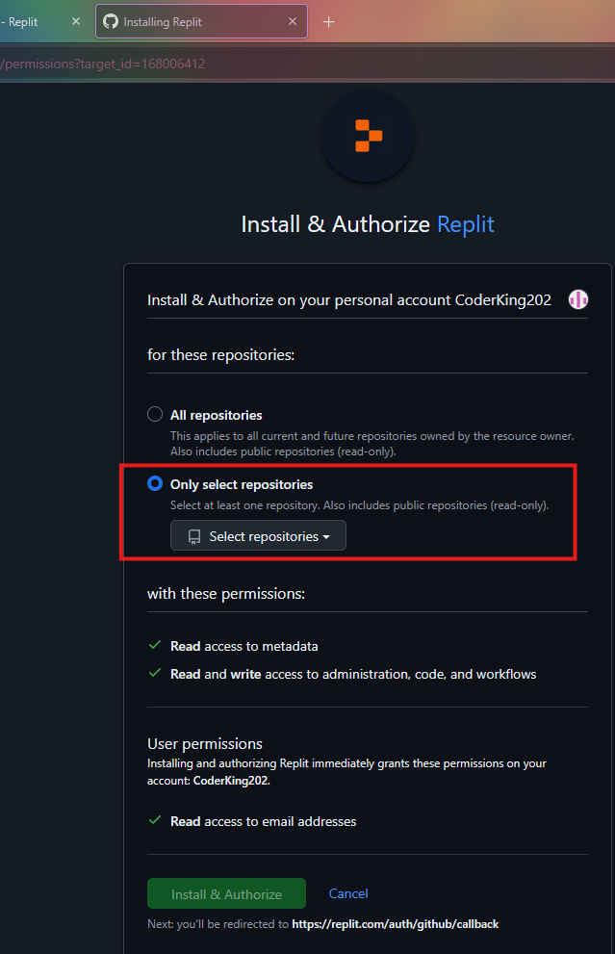

Check the only select repositories and then when you click on select repositories and then in drop down we click on Install and Authorize as marked below

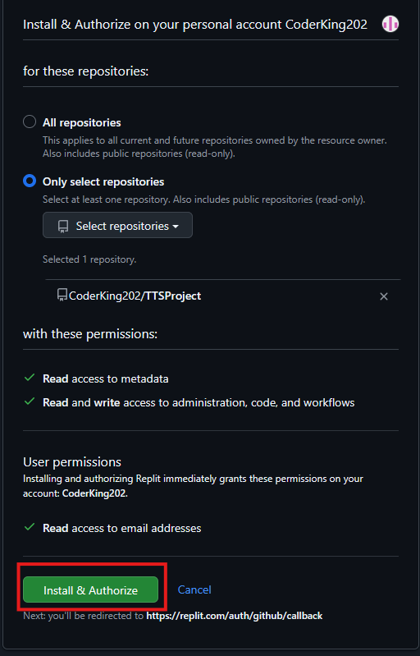

Now we choose Install and Authorize

You can access your github account by replit and then replit will be installed in Github(nay be for easy authorization or access ( who knows ) ) because I have already logged in github the browser and then replit detect the session of github maybe by cache or cookie ( who knows )

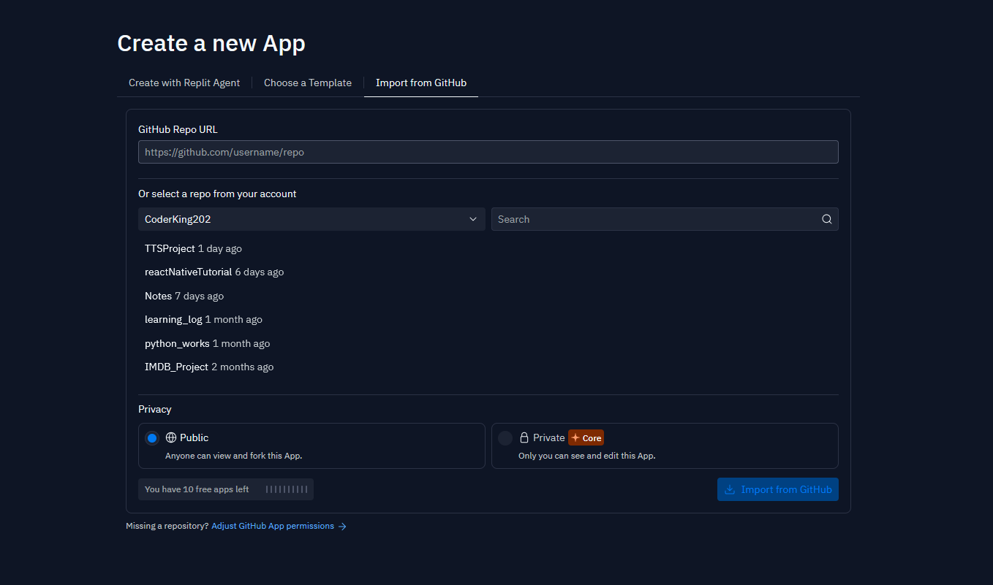

Nowe it will direct you there id don’t know why

And we will be asked to choose repository to import here

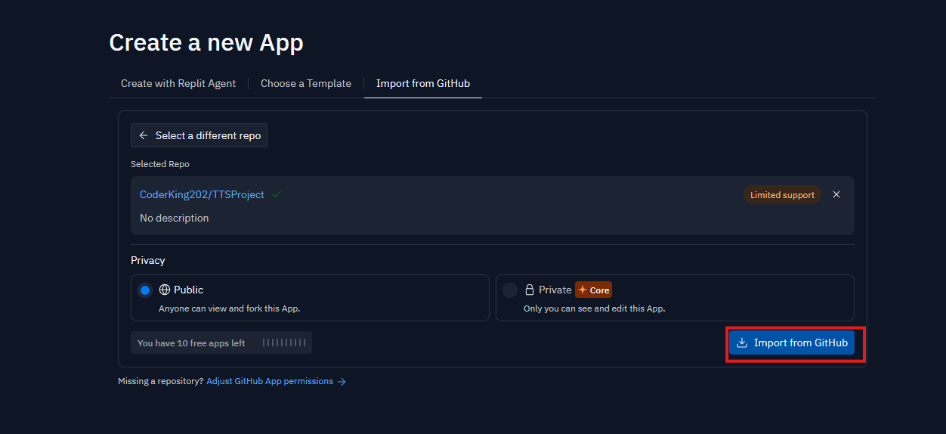

Now click on Import from Github as marked above.

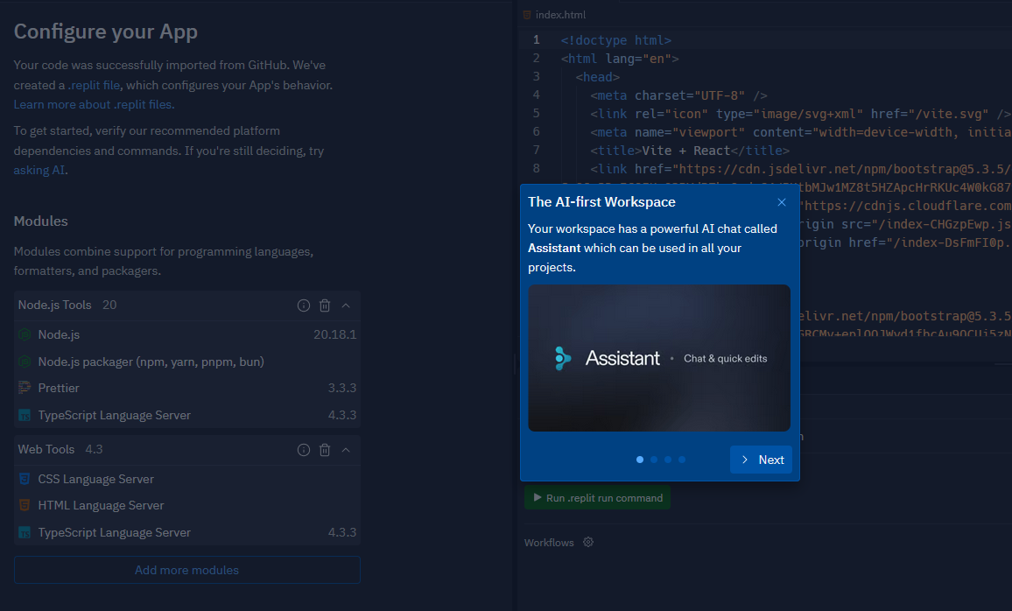

Now your project id imported and then this pop up will appear telling about AI assistant in your project Click on next

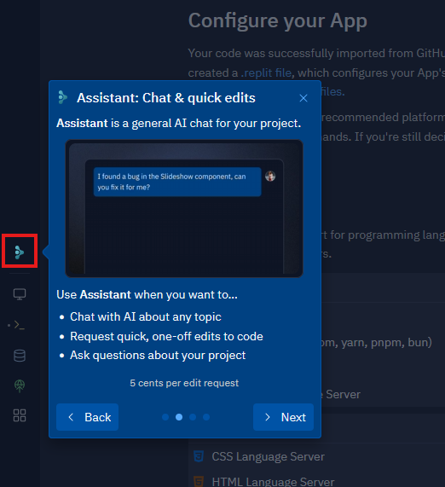

The above marked one is the button for using AI agent

Click in next

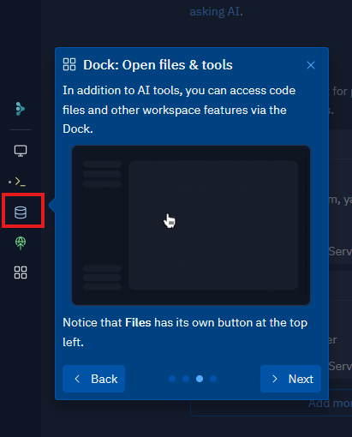

Click on the marked option to access dock tool to access files or workspace feature (who knows)

Click on next

Click on run button as marked below

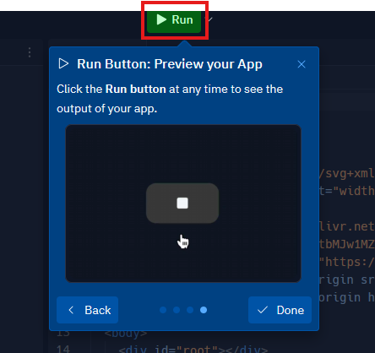

Click on Done button

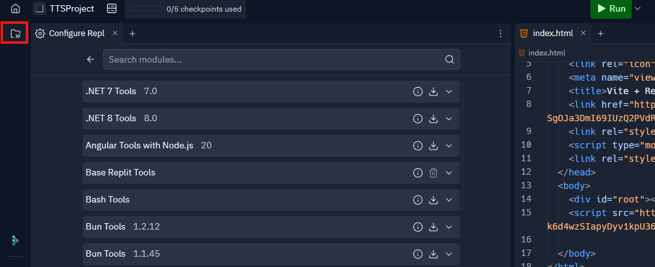

Click on marked above to show all your project files and folder after it as shown below

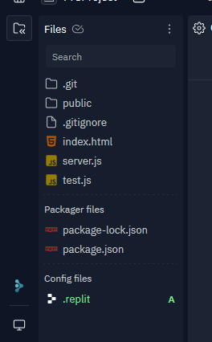

Now click on shell tab as marked below

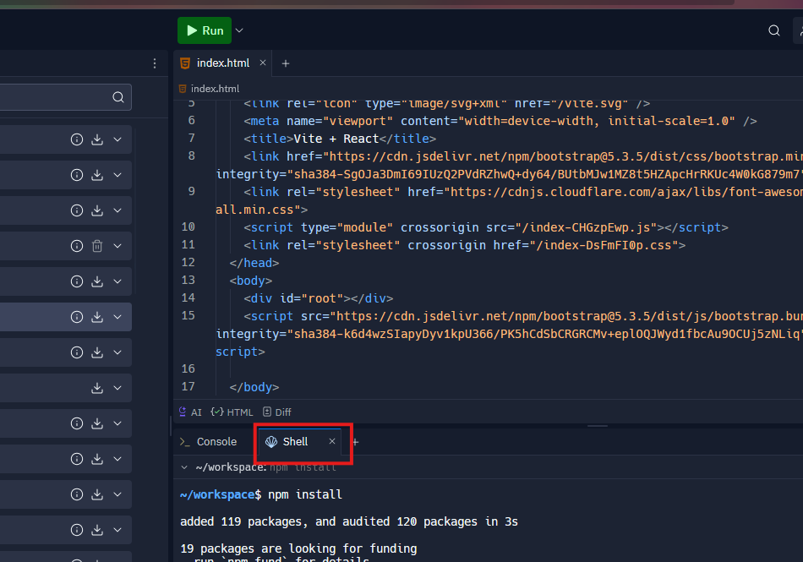

And type npm install so that node modules can be generated for our folder structure so that our code can use these dependencies

Before npm install the folder structure was like below



After npm install

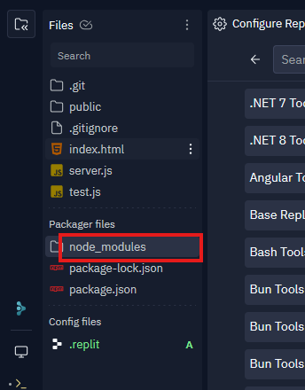

You can see the node modules generated as marked above

Now we click on run as marked below

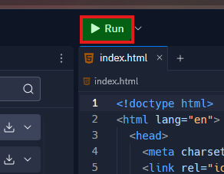

But I could not run it because since my app is node js and I think by it by mistake replit is thinking that it is a react and the command it uses to run is npm run dev but we set it to node server.js

So in my .replit file as marked below in folder structure

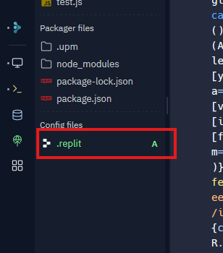

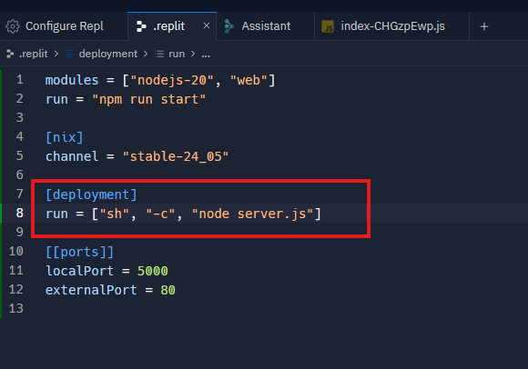

Now in above file we edit the run instead of npm run dev we did node server.js

Now if you run by pressing the run button then the app will be displayed to you in the preview tab as marked below

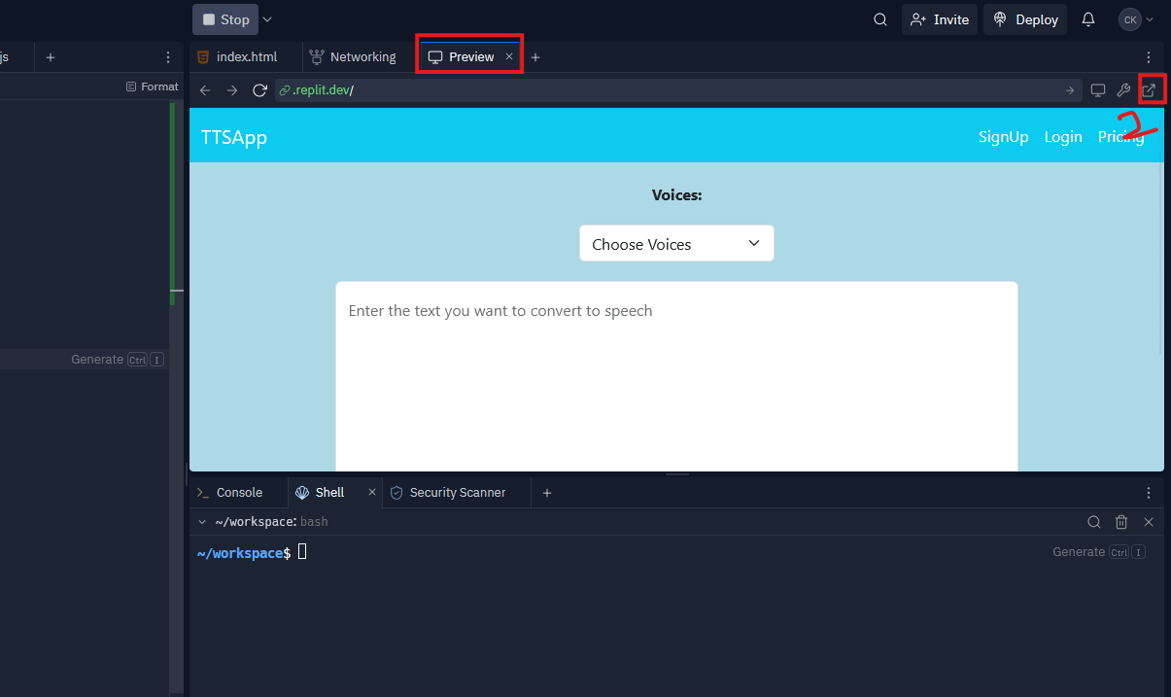

If you want open it in new tab click on marked 1 above now your app will be opened in new tab

Copy the link of the site of website from address bar as marked below

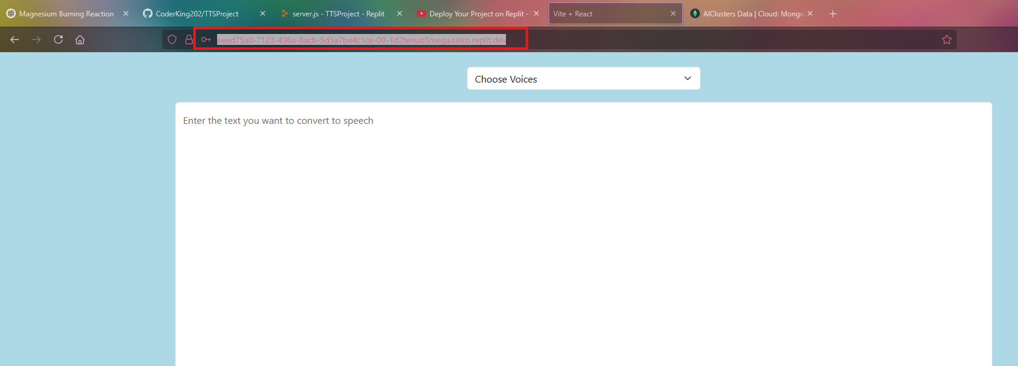

Now through this url you can access the website when the server is running in replit by run button

But we have set our front end on the basis of back in localhost but now it is in replit server so we change our js file we built after npm run build in react such that the repace <http://localhost:5000> with the ur; we copies from address bar in the new tab for the preview of website ptehr wose the front end cpuld not sent request to the back end as It is now present in replit server but not on localhost